Email Signature

Copy and paste the signature below into Microsoft Outlook:

First Last Name
Title, Department

203-254-4000, ext. 0000
jsmith@fairfield.edu
__________________________________________

Fairfield University
1073 North Benson Road
Fairfield, CT 06824-5195
DEPARTMENT OR DIVISION
__________________________________________



Update Your Mobile Email Signature

IPHONE & IPAD  - Go to Settings > Mail, Contacts, Calendar.  - Scroll down to Signature.  - On the next page, you'll have the option to write whatever you want in your sendoff line, as well as apply it "per account" or all accounts.  - If you choose per account, you can customize the signature line for each email account connected to the Mail app.  - Bonus: Update Your "From" Name While you're in those settings, you might as well check that the "from" name is what you want it to be.  - Back up a page (i.e., go to Settings > Mail, Contacts, Calendar).  - At the top during Accounts, you'll see all the accounts you have connected. Pick one by tapping it, and on the next page, pick Account. The page that pops up has a Name field. That's your "from" name.  - Note: Not all accounts contain the same fields (Gmail and Yahoo! Mail are the same, but Hotmail doesn't have all the fields, for example).  - Example image below showing the “from” name as John Smith:  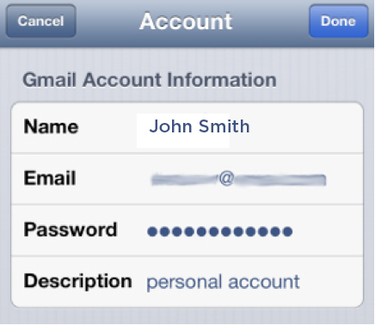  Tip: For the description, use the email address name to prevent confusion on other accounts. | ANDROID  - As with most instructions for Android phones, the details can vary slightly depending on the phone, service carrier,  and email provider. This set of instructions were validated using a Samsung Galaxy S III with MetroPCS.  - Go into your Email app and select the account you want.  - Tap the menu button and pick Settings.  - You'll see a Signature section, most likely turned on by default. On my phone, there's a slider bar to turn the signature on and off. Tap it, and you can customize the sign off.  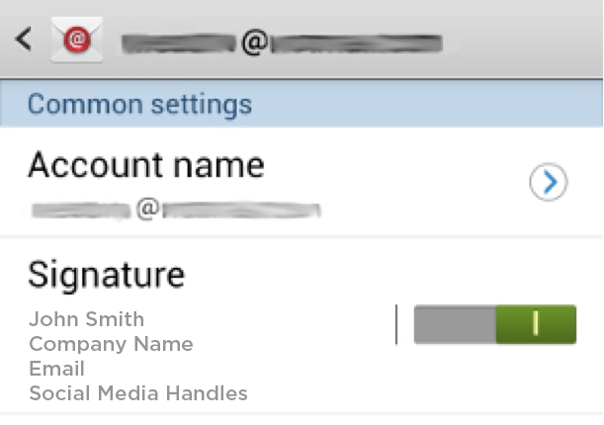  - Check and update the Account name and your name fields. Keep the Account name as the email address to prevent confusion on other accounts.

